Organ Overview Handout: Understanding Your Pet’s Test Results

Chemistry

Glucose: Glucose is the basic nutrient for the body. It is highly regulated in the blood stream, but does fluctuate for a few hours after eating. Glucose changes may be seen with a variety of metabolic diseases and various organ system abnormalities.

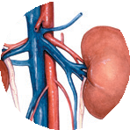Kidneys: Kidneys are responsible for filtering metabolic waste products, excess sodium and water from the blood stream which is then transferred to the bladder for excretion.
Primary Laboratory Tests for Kidneys:
BUN, CREA—metabolic waste products that the kidneys remove from the blood stream
Urinalysis—physical, chemical and microscopic evaluation of urine
Secondary Laboratory Tests for Kidneys:
Na, K, Cl, TCO2, Anion Gap–potential electrolyte imbalances PHOS, CA—potentially impacted by decreased renal function ALB—protein potentially decreased with loss through malfunctioning kidneys
Liver: The liver is a large organ with many different functions. It processes the blood by removing both bacteria and toxins as well as further breaking down many of the complex nutrients absorbed during the digestion of food into much smaller components for
use by the rest of the body.

Primary Laboratory Tests for Liver:
ALT—liver cell enzyme indicating liver cell injury
ALKP, GGT—liver enzymes that may support bile obstruction ALB—protein produced in liver potentially decreased with impaired liver function
Secondary Laboratory Tests for Liver:
BUN, GLU, GLOB—potential indicators of decreased function TBIL, CHOL—potential support for bile obstruction TRIG—potential indicator of lipid metabolism dysfunction
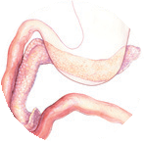Pancreas: The pancreas is a small organ located near the small intestines and is responsible for producing several digestive enzymes and hormones that help regulate metabolism.
Primary Laboratory Tests for Pancreas:
AMYL, LIPA—pancreatic enzymes potentially supporting cell injury/inflammation
BUN, CREA—if increased, may interfere with AMYL
interpretation

Secondary Laboratory Tests for Pancreas: GLU—potential indication of diabetes related to pancreatic disease
CA, ALB—potential decrease associated with pancreatic inflammation
ALT, ALKP, GGT, TBIL, CHOL, TRIG—potential secondary liver disease
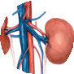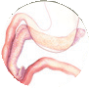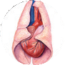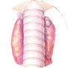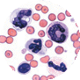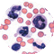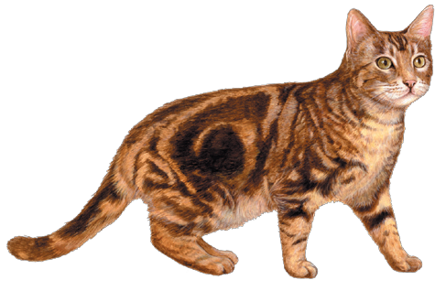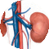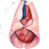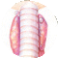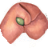Electrolytes: Electrolytes (NA, K, CL, TCO2, Anion Gap) are critical to body function and must be maintained in very narrow limits. Dehydration is a common cause of electrolyte imbalances, despite how effective the body is at regulating the concentration levels.
Hematology

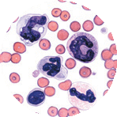Red Blood Cells: Red blood cells (RBCs) are the most numerous and longest living of the different types of blood cells and typically make up almost half of the blood’s volume. RBCs contain a special protein called hemoglobin (HGB) that binds to the oxygen in the lungs and enabled the RBC to transport the oxygen as it travels through the rest of the body. Reticulocytes are immature red blood cells and are produced by the bone marrow.
RBC, HCT, HBG—measures of red blood cell mass MCV, MCH, MCHC, RDW—measurements describing the RBCs
RETIC—immature RBCs increased during times of increased RBC production
White Blood Cells: White blood cells are primarily responsible for fighting infections. There are five different types of white bloods cells and each one performs specific functions to keep the body healthy.
NEU—Neutrophils are most common and help fight bacterial infections
LYM—Lymphocytes are a component of the immune system and produce antibodies
MONO—Monocytes ingest large particles and help clear areas with tissue injury
EOS—Eosinophils are involved in allergic responses and parasitic diseases
BASO—Basophils are uncommon and are involved in allergic and parasitic disease.
Platelets: Platelets play a critical role in preventing bleeding.

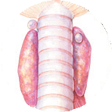Thyroxine: Thyroxine (T4), produced by the thyroid gland, is a hormone essential for growth and metabolism.

Urine

Urinalysis: Urinalysis includes physical, chemical and microscopic evaluation of urine and this evaluation provides additional information about the kidney and liver as well as the general well being of animals.

© 2009 IDEXX Laboratories, Inc. All rights reserved. • 09-68166-00
All ®/TM marks are owned by IDEXX Laboratories, Inc. or its affiliates in the United States and/or other countries.

