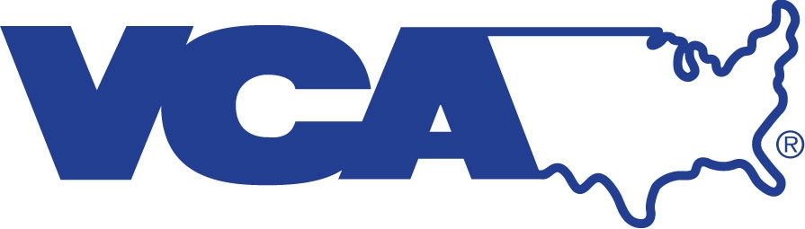 | VCA Animal Specialty Group  Out-patient Ultrasound Referral Form

Referring Hospital: _______________________________Referring Veterinarian_____________________________
Address: _________________________________________________________________________________________ Phone number: __________________________________Fax: ______________________________________________ Email: __________________________________________

Client/Patient Information

Owner’s Name Address Phone Number
__________________________________________________________________________________________________
Pet’s Name Species Dog/Cat Breed

__________________________________________________________________________________________________
Sex Spayed/Neutered Date of Birth/ Age Color

History- Please provide as much detail as possible. The scan will not be performed if not completed

__________________________________________________________________________________
__________________________________________________________________________________
__________________________________________________________________________________
__________________________________________________________________________________
__________________________________________________________________________________

Please choose the following Ultrasound Study:

⃝ Abdominal: $499.70
⃝ Dual Cavity: $977.50
⃝ Check for pericardial fluid only (screening for right atrial hemangiosarcoma): $162.05
⃝ Neck/Thyroid/Parathyroid: $237.30

*Please note: Clients should expect that their pet will be in our hospital for 2-3 hours for the ultrasound. All pets need to arrive fasted. Please let the client know that we will be shaving the pet’s belly for the ultrasound. On occasion, “Out-patient ultrasound” cases may arrive unstable or in need of veterinary treatment. These cases may be converted into a clinical consult. The consultation fee is $194.00.
For hospital use only:
Approved
Scheduled _________

As always we appreciate your referrals!

Dr. Chelsea Kunst, DVM, DACVR
Dr. Jonathan Hayles, DVM, MS, DACVR

VCA Animal Specialty Group
5610 Kearny Mesa Road, Suite B, San Diego CA 92111 (858) 560-7778 Fax (858) 560-7762
An Ultrasound will not be performed without providing a recent history

