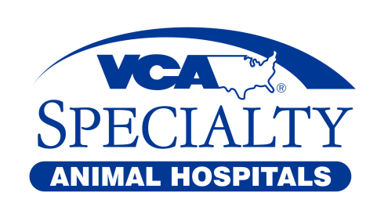
VCA Great Lakes Veterinary Specialists
4760 Richmond Rd
Warrensville Heights, OH 44128
TEL: 216-831-6789
FAX: 216-831-4653

DIABETIC QUESTIONAIRE

Please answer all questions

Date: _______ Time: _______

Patient Name:

Owner Name:

How is your pet’s water intake and urinations? _______________________________
How is your pet’s appetite? _____________ Last time your pet ate? ____________
What food (brand, wet/dry)? _____________________________ Amount ___________
Treats or "people food" your pet eats: _______________________________________

Insulin: What type given? __________ Amount given: _______ Time given: _______

Other medication (amounts and times given): __________________________________
Any medication recently changed, added, or discontinued since last visit? _______________________________________________________________________

Other Concerns: __________________________________________________________

At what number can you be reached today? _________________________________

----------------------------------------OFFICE USE ONLY------------------------------------------
Weight: _______ BG Curve:
Time | Value

Discharge Instructions:
Insulin Dose: ____________________ Other Meds: _________________________
Diet: ___________________________ Recheck: ____________________________
If your pet does not eat, give 1/2 insulin dose. If he/she does not eat a second meal, give 1/2 insulin dose and bring him/her to a veterinarian. Please call sooner or bring your pet in if he/she starts vomiting, has diarrhea, or if you notice shaking, trembling, seizures, or if you are otherwise concerned.

