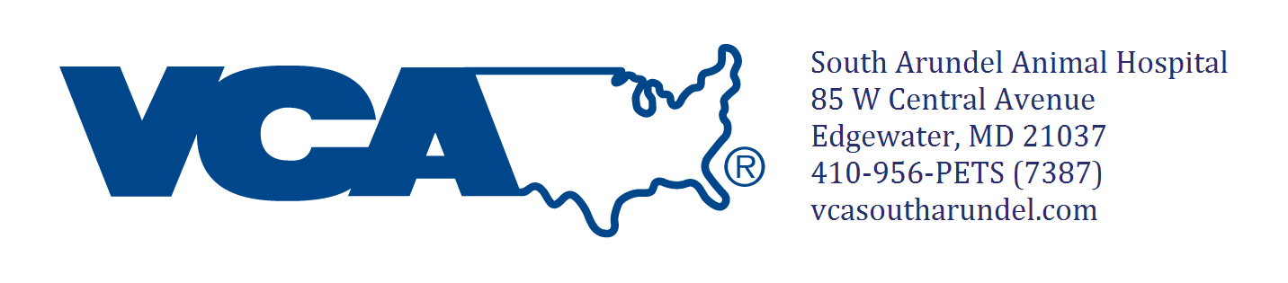
Staff Use Only:
- Billed
- Scanned/Attached
_____Staff initials

Place label here

Can you be reached while away?
If yes which is best? (circle one) Main # Cell # Text Message Email: Other

South Arundel Canine Boarding Release Form

Check-in Date: Check-out Date:

In case of an emergency contact name & phone number:

Date of last flea/tick preventative application: Flea/Tick product used:____________

If we see any fleas on your pet while boarding, he or she will be treated at your expense.

Is your animal thunder phobic? If yes, describe his/her reaction & how you usually handle it:

GROUP PLAY

Does your dog get along with other dogs? YES NO

If yes do you authorize group playing? YES NO Initials_____________

Medications Are you providing your own detailed medication sheet: Yes No

Please list your pet’s medications here:

1. __________________ Directions: ______________________________________ Last time given: ______________________
2. __________________ Directions: ______________________________________ Last time given: ______________________
3.__________________ Directions: ______________________________________ Last time given: ______________________
4. __________________ Directions: ______________________________________ Last time given: _______________________
Feeding Instructions

Does your pet have any food allergies OR restrictions? Yes No If yes explain:

Quantity:_________________________ How often? _________________Time of last meal:___________

Does your dog shred toys, pull out stuffing, or destroy beds? Yes No

Belongings What other belongings are you dropping off with your pet? We recommend labeling all belongings.

Any Special Instructions or Notes:

Pet is due for the following services (required for boarding): ___________________________________________________

Do you authorize us to complete these items (circle one) YES NO Initial here __________

Additional services available- please initial if requested (additional charges apply):

________Extra walk
________15 min playtime
________Bath with technician (includes nail trim and ear cleaning)
________Nail trim only
________Anal Gland expression
________Exam by veterinarian
Grooming services:
________Professional Grooming (includes bath and haircut, nail trim, ear cleaning, and anal glad expression)
Grooming Notes: _______________________________________
__________________________________________________________________________________________________________________________________________________________________
________Extra Brush out
________Furminator treatment
________Nail grinding (dremel)
_______Teeth brushing
Please initial that you have read and agree to the following:

_________I understand that my pet must maintain a once yearly exam at VCA South Arundel Animal Hospital. Pet must also have a fecal sample checked for parasites every 6 months, as well as updated vaccines.

_________Should illness, injury, or circumstances warrant the need for emergency services, I understand that the hospital will try to contact me or the individual indicated as the emergency contact before treatment, but must exercise the option to proceed if no one is available for clearance. I understand that I will be responsible for all charges incurred for such treatment for my pet.

Signature Date

Staff use only (initial when completed):

CSR check-in: ___________ Tech check-in_____________
Kennel size: _____________ 2nd tech check_____________
Pet’s weight_____________ All services were provided (tech) ____________

